Multithreading in Java

Introduction of Multitasking : -
Executing the multiple tasks simultaneously is the concept of multitasking
There are two type of multitasking :-
- Process based multitasking.
- Thread based multitasking.
Processed Based Multitasking :-
Executing several tasks simultaneously and each task have independent separate process is called PBM
Thread Based Multitasking :-
Executing several task simultaneously where each task have independent separate part of the same program is called TBM.

Some important areas of application where multithreading are used :
- To implement multimedia graphics
- To develop animations
- To develop web application and application servers
- To develop video games
Whether its process based or thread based the main objective is to improve the performance of the program.

The way to define instantiate and start a new Thread
We are defining thread in following two ways :-
- To Extend Thread class
- To Implement Runnable Interface

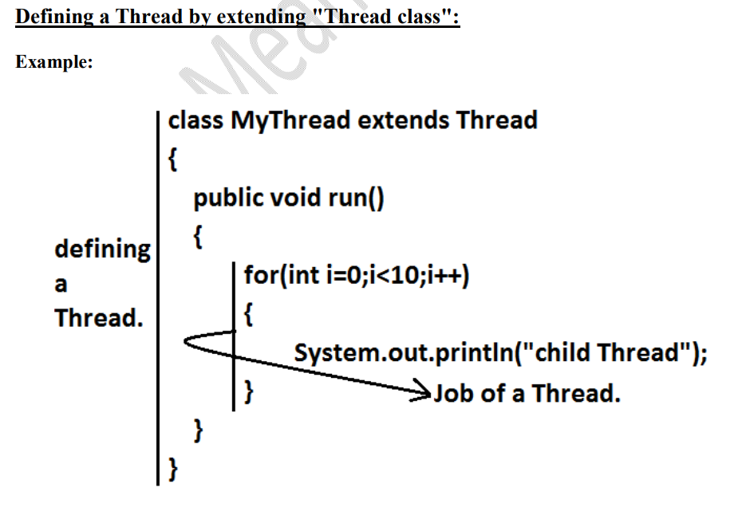
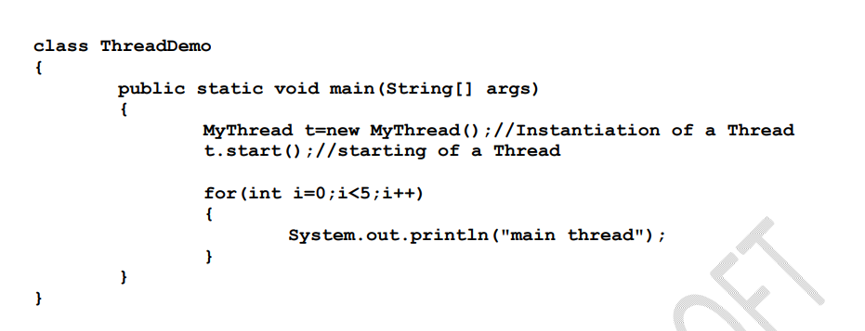

When we run the above program then output will not predictable it will depends on Thead scheduler which is maintain by JVM and we cannot decide the order of output

What is difference between run() and start() method?
In case of start()
We use start method then a new Thread will create and responsible for executing the run method.
But when we use run() method then no new Thread will create and run() will execute same as normal method by main Thread.
When we are called t.start() then
- New Thread will create and register will thread scheduler
- All other mandatory low level activity.
- Invoke run()

Note :-
- If want to overload run() method then thread class start() method will invoke no args run() method And if you override the Thread class start() method then our start() method will invoke as normal method call and no new thread will start.
- After starting a thread we can't restart the same thread otherwise it will give us IllegalThreadStateException
Example : -
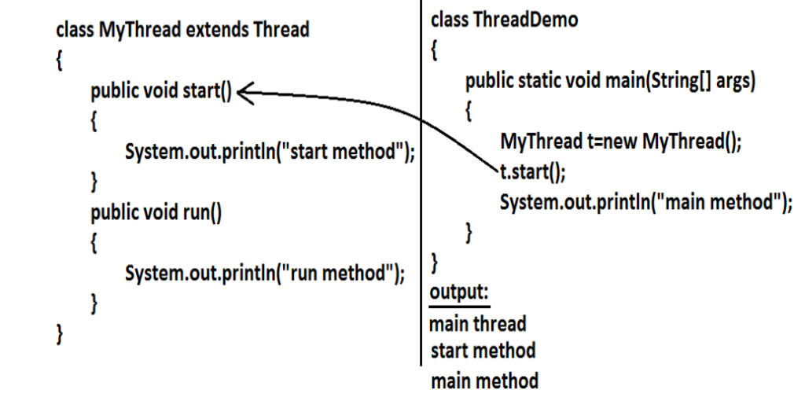

Example 2 :-
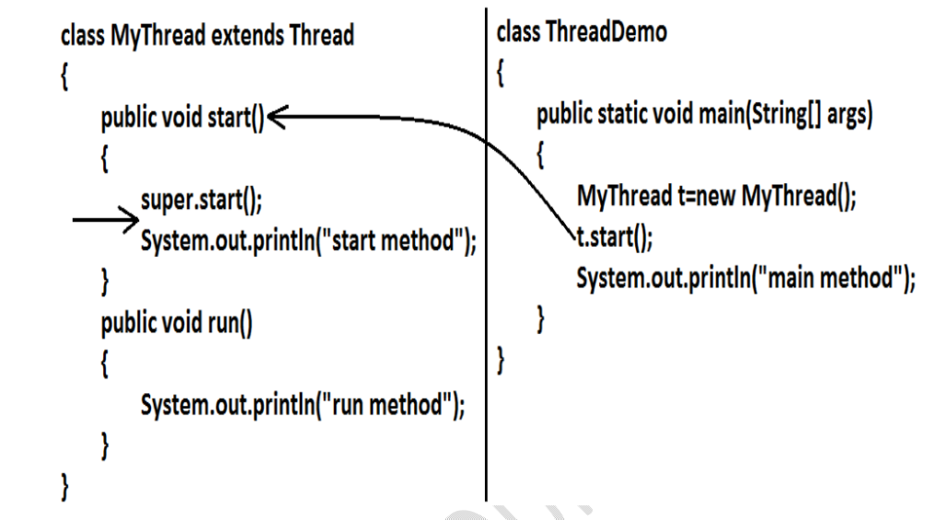

Output
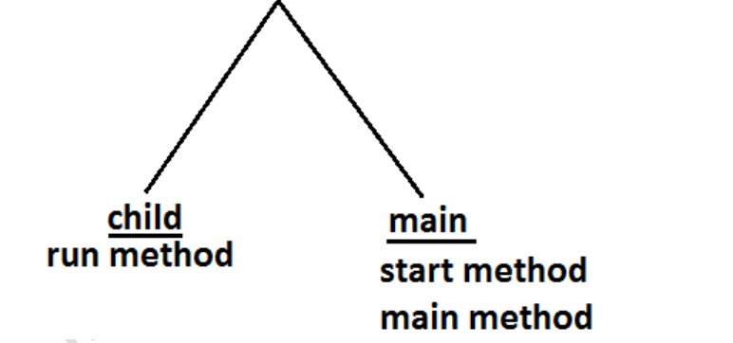

Life Cycle of the Thread

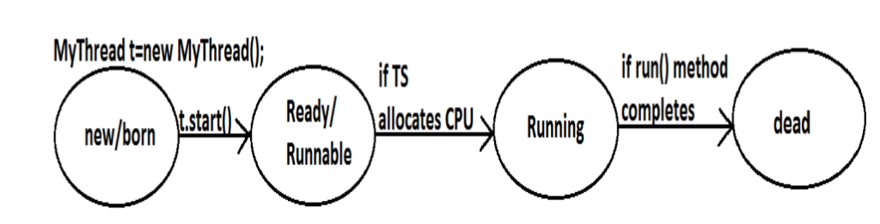

Now we can define a thread by implementing Runnable Interface

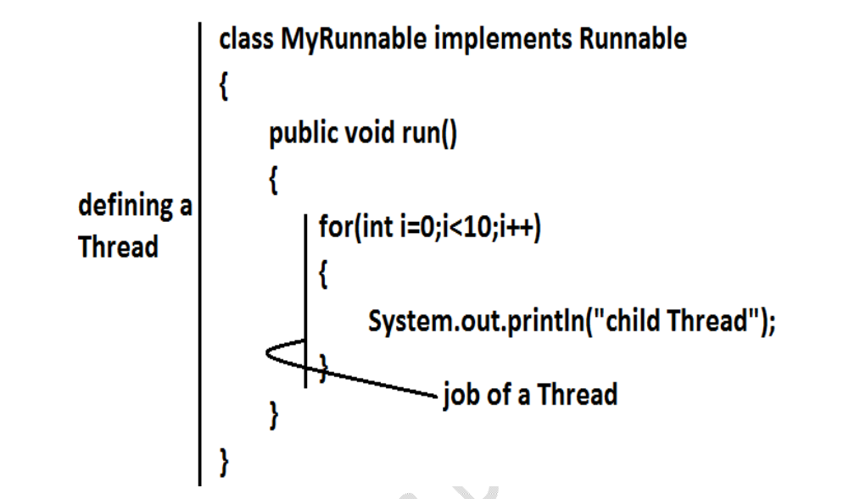

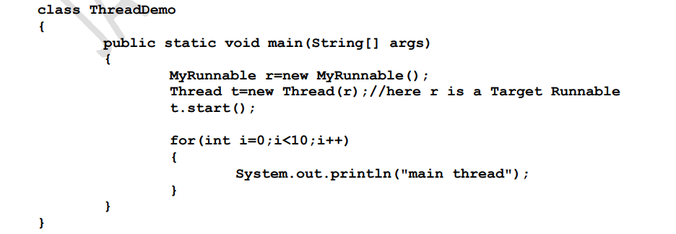

Getting and setting the Thread Name

Every thread in java has a name which provided by explicitly by user or automatically provided by JVM
Thread class have method which we can use to get and set the name of thread.
Example : -

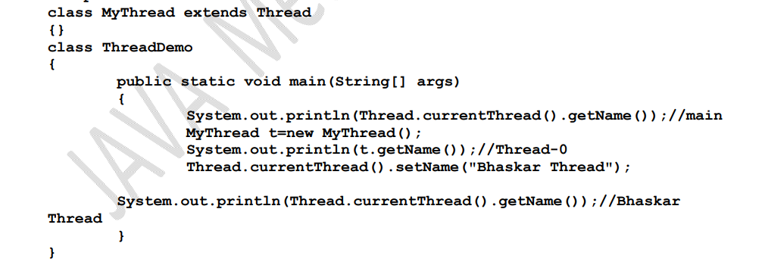

Thread Priority

Every thread in java has some priority it may be provided by explicitly by user or automatically provided by JVM
The valid range of Thread priority is 1 to 10 not (0 to 10) where 1 have least priority and 10 have highest priority
Thread class have defined some constant to represent some standard priority
- Thread. MIN_PRIORITY----------1
- Thread. MAX_PRIORITY----------10
- Thread. NORM_PRIORITY--------5
Default priority
Default priority only for main thread is 5. but all the remaining Threads priority will be inheriting
from parent to child
Example :-

The Methods to Prevent a Thread from Execution:-

We can prevent(stop) a Thread execution by using the following methods.
- yield();
- Join();
- Sleep();

yield():
- yield() method causes "to pause current executing Thread for giving the chance of remaining waiting Threads of same priority".
- If all waiting Threads have the low priority or if there is no waiting Threads then the same Thread will be continued its execution.
- If several waiting Threads with same priority available then we can't expect exact which Thread will get chance for execution.
- The Thread which is yielded when it get chance once again for execution is depends on mercy of the Thread scheduler.
- public static native void yield()

Example :

In the above program child Thread always calling yield() method and hence main Thread will get the chance more number of times for execution. Hence the chance of completing the main Thread first is high.

Join() :-
If a Thread wants to wait until completing some other Thread then we should go for join() method. Example: If a Thread t1 executes t2.join() then t1 should go for waiting state until completing t2.

Sleep() method : -
If a Thread don't want to perform any operation for a particular amount of time then we should go for sleep() method.

Synchronization
- Synchronized is the keyword applicable for methods and blocks but not for classes and variables.
- If a method or block declared as the synchronized then at a time only one Thread is allow to execute that method or block on the given object.
- The main advantage of synchronized keyword is we can resolve date inconsistency problems.
- But the main disadvantage of synchronized keyword is it increases waiting time of the Thread and effects performance of the system.
- Hence if there is no specific requirement then never recommended to use synchronized keyword.
- Internally synchronization concept is implemented by using lock concept.
- Every object in java has a unique lock. Whenever we are using synchronized keyword then only lock concept will come into the picture.
- If a Thread wants to execute any synchronized method on the given object 1st it has to get the lock of that object. Once a Thread got the lock of that object then it's allow to execute any synchronized method on that object. If the synchronized method execution completes then automatically Thread releases lock.
- While a Thread executing any synchronized method the remaining Threads are not allowed execute any synchronized method on that object simultaneously. But remaining Threads are allowed to execute any non-synchronized method simultaneously. [lock concept is implemented based on object but not based on method].

Example

Class level lock:
- Every class in java has a unique lock. If a Thread wants to execute a static synchronized method then it required class level lock.
- Once a Thread got class level lock then it is allow to execute any static synchronized method of that class.
- While a Thread executing any static synchronized method the remaining Threads are not allow to execute any static synchronized method of that class simultaneously.
- But remaining Threads are allowed to execute normal synchronized methods, normal static methods, and normal instance methods simultaneously.
- Class level lock and object lock both are different and there is no relationship between these two.

Synchronized Block :-
Some time we need only few like to thread safe in that case we can't use sync in method level boz it will block tha other treads to execute that method so at that time we need to use sync block. And it aslo improve the performace of the application

NOTE :
- The statements which present inside synchronized method and synchronized block are called synchronized statements or critical section.
- When we are not using sync then result will unpredictable then it's called race condition.
- When we resolve the race condition and only one thread will access the critical section at same time its called
mutual exclusion(prevent)

LOCKING
Every object in java has a unique lock. Whenever we are using synchronized keyword then behind the picture
lock is performing
There are two of Lock :-
- Intrinsic
- Explicit
Intrinsic lock :-
These are built into every object in java. We don’t see them, but they're there. When we use synchronized keyword, you are using these automatic locks.
Explicit Lock :-
These are more advanced locks we can control ourself using the Lock class from Java.util.concurrent.locks.
You are explicitly say we when to lock and unlock, giving our control over how and when people can use sync statement.
Lock : -

A lock helps in controlling access to a shared resource by multiple threads. Only one thread at a time can acquire the lock and access the shared resource.
If a second thread attempts to acquire the lock on shared resource when it is acquired by another thread, the second thread will wait until the lock is released. In this way we can achieve synchronization and race conditions can be avoided.
Some Important method if Lock interface
Modifier and Type | Method | Description
void | lock() | Acquires the lock.
void | lockInterruptibly() | Acquires the lock unless the current thread is interrupted.
Boolean | tryLock() | Acquires the lock only if it is free at the time of invocation.
Boolean | tryLock(long time, TimeUnit unit) | Acquires the lock if it is free within the given waiting time and the current thread has not been interrupted.
void | unlock() | Releases the lock.

Understanding ReentrantLock
Reentrant is a type of lock that allows a thread to acquire the same lock multiple times without blocking itself. In simpler terms, if a thread that already holds the lock attempts to acquire it again, it won’t be stopped or placed into a waiting state. This is especially useful in recursive methods, where a thread might call itself and need to re-acquire the lock each time without deadlocking.
Example :-

In this code, lock.lock() acquires the lock, and lock.unlock()

Method of ReentrantLock -
Lock()
- Acquires the lock, blocking the current thread until the lock is available. It would block the thread until the lock become available .
- If the lock is already held by another thread, the current thread will wait unit it can acquire the lock.

TryLock()
- Tries to acquire the lock without waiting. Return true if the lock was acquired, false otherwise.
- This is non-blocking, means the thread will not wait if the lock is not available.

TryLock(long timeout, TimeUnit unit)
- Attempts to acquire the lock, but with a timeout. If the lock is not available, the thread waits for the specified time before giving up. It is used when you want to attempt to acquire the lock without waiting indefinitely. It allows the thread to do other work if the lock is not available. And this approach is avoid the deadlock scenarios.
- Return true if the lock was acquired, false otherwise.
Unlock()
- Releases the lock held by the current thread.
- Must called in a finally block to ensure that the lock is always released even if an exaction is occurs.

LockInterruptibly()
Acquires the lock unless the current thread is interrupted. This is useful when you want to handle interruptions while acquiring a lock.

Fairness of Locks
- Fairness is the context of lock refers to the order in which thread acquire a lock. A fair lock ensures that threads acquire the lock in the order they requested it.
- Fair locking ensures that the longest-waiting thread gets the lock next, reducing the risk of starvation, where some threads might never acquire the lock. Fair locks, however, might introduce more overhead and slower throughput, so their use depends on the requirements of the application.

Difference between ReentrantLock and Synchronized

Sr. No. | Key | ReentrantLock | Synchronized
1 | Acquire Lock | Reentrant lock class provides lock() methods to get a lock on the shared resource by thread | You need to just write synchronized keyword to acquire a lock
2 | Release Lock | To release lock , programmers have to call unlock() method | It is done implicitly
3 | Ability to interrupt | lockInterruptibly() method can be used to interrupt the thread | There is no way to interrupt the thread
4 | Fairness | Constructor of this class has fairness parameter. If it is set to true then locks favor granting access to the longest-waiting  * thread | Lock does not guarantee any particular access orde
5 | Lock Release Order | Lock can be released in any order | Lock should be released in the same order in which they were acquired

ReadWrite Lock :-
A Read-Write lock is a concurrency control mechanism that allows multiple threads to read shared data simultaneously while restricting write access to a single thread at a time. This lock types, provided by the ReentrantReadWriteLock class
In java, optimizes performance in scenarios with frequent read operations and infrequent writes.
if a read lock is active, any attempt to acquire a write lock will usually be forced to wait until all existing read locks are released. This ensures data consistency and prevents readers from seeing an inconsistent state while a write operation is in progress
Example :-

DeadLock :-
A deadlock in Java occurs when two or more threads are blocked forever, each waiting for the other to release a lock. This typically happens when multiple locks are acquired in different orders by different threads. Example Explanation:
- Thread 1 locks lock1 and waits for lock2.
- Thread 2 locks lock2 and waits for lock1.
Both threads are stuck, causing a deadlock.
Example :-
public class DeadlockExample {
private final Object lock1 = new Object();
private final Object lock2 = new Object();

public void method1() {
synchronized (lock1) {
System.out.println("Thread 1: Holding lock1...");
try { Thread.sleep(100); } catch (InterruptedException e) {}
synchronized (lock2) {
System.out.println("Thread 1: Acquired lock2!");
}
}
}

public void method2() {
synchronized (lock2) {
System.out.println("Thread 2: Holding lock2...");
try { Thread.sleep(100); } catch (InterruptedException e) {}
synchronized (lock1) {
System.out.println("Thread 2: Acquired lock1!");
}
}
}

public static void main(String[] args) {
DeadlockExample example = new DeadlockExample();
new Thread(example::method1).start();
new Thread(example::method2).start();
}
}

ThreadPoolExecutor :-
ThreadPoolExecutor is part of java.util.cconcurrent package and it provides a flexible and efficient way to manage multiple worker threads for executing tasks asynchronously. Instead of the creating a new thread for each task, it maintain a pool of thread and reuses them.

